"Kyiv Professional College of Communication"

Cycle Commission of Computer Engineering

REPORT ON THE IMPLEMENTATION

LABORATORY WORK №5

in the discipline: "Operating systems"

Topic: « Learn how to navigate the file system and manage

files and directories»

Performed by a student

of the group BICS-13

Los Zlata Volodymyrivna

Checked by the teacher

Sushanova V.S.

Kyiv 2024

**Objectives:**

1. Gaining practical skills in working with the Bash shell.

2. Familiarity with basic file system navigation commands.

3. Familiarity with basic commands for managing files and directories.

**Material support of classes:**

1. Computer such as IBM PC.

2. Windows operating system (Windows 7).

3. Virtual machine - Virtual Box (Oracle).

4. GNU/Linux operating system - CentOS.

5. Cisco Networking Academy website netacad.com and its online Linux courses.

**Tasks for preliminary preparation.**

**1. Read the brief theoretical information for the lab and make a small glossary of basic English terms on command assignments and their parameters.**

**Globbing** is a simple pattern matching language.

**2. Based on the material reviewed, answer the following questions:**

2.1. Compare the file structures of a Windows-like and Linux-like system.

1. File System:

- Windows: Uses the NTFS (New Technology File System) or FAT (File Allocation Table) file system.

- Linux: Uses various file systems such as ext4, Btrfs, XFS, and can also support NTFS through additional programs.

2. Directory hierarchy:

- Windows: Has a hierarchical structure with drives (e.g., C:, D:) and special directories such as Program Files, Windows, Users, etc.

- Linux: Has a single hierarchical structure, starting with the root directory (/), which contains directories such as bin, etc, home, var, etc.

3. Separation of System and User files:

- Windows: Usually uses a separation between program and user files, such as Program Files for programs and Users for user files.

- Linux: All files are usually located in the same hierarchy, but there is a concept of separation between system and user files, usually in /usr and /home respectively.

4. Advanced File Attributes:

- Windows: Has support for advanced file attributes such as security attributes, additional file information, etc.

- Linux: May have attributes such as permissions, file owner, group, etc., but not as advanced as Windows.

5. Manage Access Rights:

- Windows: Uses an ACL (Access Control Lists) system to manage access rights.

- Linux: Uses the UNIX access rights system (sometimes extended to POSIX ACLs) to manage access rights.

6. Symbolic Links:

- Windows: Supports symbolic links (if the corresponding functionality is enabled, for example, via mklink).

- Linux: Supports symbolic links via the ln command.

In general, both systems have their own unique features in file structure and file management, but many of the basic concepts are similar.

2.2. Explain the concept of FHS. How is this standard used in the context of file systems?

**FHS (Filesystem Hierarchy Standard )** is a standard that defines the basic rules for organizing files and directories in Unix-like systems, including Linux. The FHS standard helps to ensure consistency between different Linux distributions, making it easier for users and developers to work with the system, as well as ensuring compatibility between different distributions.

2.3. List the basic commands for working with files and directories in Linux: create, move, copy, delete.

**Create files and directories:**

- `touch <file_name>` : Creates an empty file or changes the timestamps of an existing file.

- `mkdir <directory_name>` : Creates a new directory.

**Moving and renaming:**

- `mv <source> <target>` : Moves a file or directory from one location to another, or renames a file or directory. If the ``target'' is an existing directory, the ``source'' is moved to that directory.

**Copy:**

- `cp <source> <target>` : Copies files and directories. To copy directories, the `-r` (recursive) option is usually used, which allows you to copy directories along with their contents.

**Delete:**

- `rm <file>` : Deletes files. If you want to delete a directory with its contents, use the `-r` (recursive) and `-f` (force) options, for example, `rm -rf <directory>`.

- `rmdir <directory>` : Removes empty directories.

**3. Study the materials of the Cisco Academy online course "NDG Linux Essentials":**

* Chapter 7 - Navigating the Filesystem
* Chapter 8 - Managing Files and Directories

**4. Take the NDG Linux Essentials exam on the following topics:**

- Chapter 07 Exam

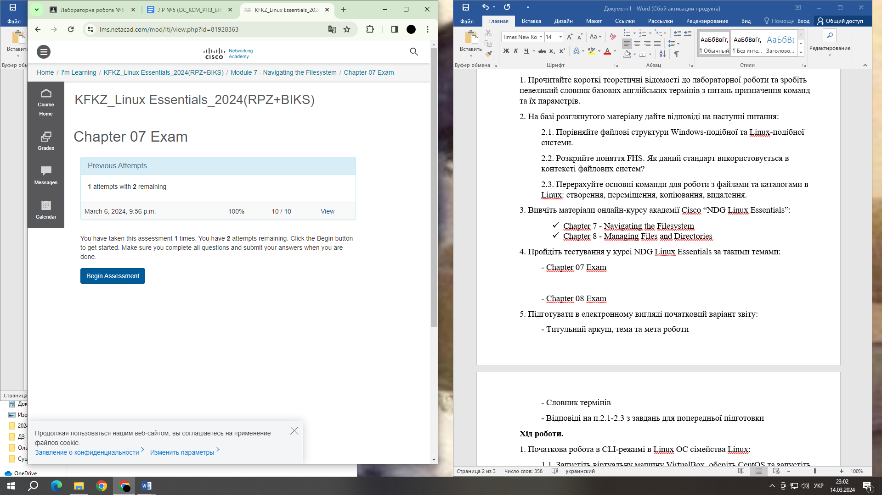

- Chapter 08 Exam

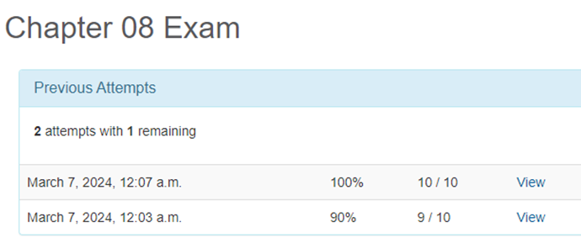

**5. Prepare an initial version of the report in electronic form:**

- Cover sheet, topic and purpose of the work

- Glossary of terms

- Answers to p.2.1-2.3 from the preliminary preparation tasks

**Procedure.**

1. Initial work in CLI mode in the Linux OS of the Linux family:

1.1. Start the VirtualBox virtual machine, select CentOS, and start it. Log in to the system as a user: CentOS, login password: reverse (if you are performing the LP in 401) and launch the terminal.

1.2. Start the Ubuntu_PC virtual machine (if you are performing the PL task through the netacad academy)

1.3. Start your Linux operating system (if you are working on your own PC and have installed it) and launch the terminal.

2. Work through all the sample commands presented in the labs of the NDG Linux Essentials course - Lab 7: Navigating the Filesystem and Lab 8: Managing Files and Directories. Create a table to describe these commands***.

|  |  |
| --- | --- |
| Command name | Its purpose and functionality |
| pwd | Determines the location of the user in the file system, shows the current working directory (print working directory). |
| cd Documents | The cd command navigates to the directory specified as an argument. In this case, it is the Documents directory. |
| echo ~ ~sysadmin ~root ~mail ~nobody | It is used to display the home directories of the current user (represented by the first ~ character) and the users sysadmin, root, mail, nobody, respectively, if they exist. |
| cd /usr/bin | Changes the current working directory to /usr/bin. |
| cd bash | Change the current working directory in the command prompt. |
| cd ../dict | Using cd ../dict will take you to the dict directory, which is one level above your current working directory. |
| ls -a | Prints a list of files and directories in the current working directory. The -a option tells ls to list all files and directories, including hidden ones. |
| ls -d /etc/???? | The -d option tells ls not to print the contents of each directory specified, but to print the name of each directory specified as an argument. |
| echo /etc/t* | It displays paths to files or directories that start with t and are located in the /etc/ directory, with or without an extension. |
| echo /etc/*.d | It will display the paths to files or directories that are located in the '/etc/' directory and have the extension '.d'. |
| echo /etc/r*.conf | It will display paths to files that start with r and have the .conf extension in the /etc/ directory. |
| cp source destination | Copies a file or directory from the source path to the destination path. |
| cp | This program is designed to copy files and directories. It allows you to create duplicates of files and directories in the file system. |
| mkdir | Designed to create new directories (folders) in the file system. |
| touch | It is used to create an empty file or to change the access time and modify the modification time of an existing file. |
| mv | It is used to move or rename files and directories. |

**3. Work in the terminal (consolidation of practical skills), be sure to submit your screenshots:**

**4. Describe the actions that the commands perform to move through the directory system:**

**- The cd / - command** - moves you to the root directory of the file system. This is the highest level of the directory structure in the system.

**- cd /home** - moves you to the /home directory, which usually contains the home directories of users.

**- cd ~ command** - this command moves you to your home directory. The ~ dot points to the current user's home directory.

**- cd command (without argument )** - moves to the current user's home directory, similar to cd ~.

**- cd .. command** - moves one level higher in the directory structure. For example, if you are in the /home/user/Documents directory, then this command will move you to the /home/user directory.

**- The command cd ../...** - moves two levels higher in the directory structure.

**- cd - command** - moves to the previous working directory. This command allows you to quickly return to the previous location where you were.

**Checklist questions**

1. How can you view the path to a user's home directory using the echo command? There are 2 ways, give both examples in the terminal (the answer is in the cisco academy materials on netacad.com)

2. Is it possible to view the contents of the root directory while in the user's home directory without going to the root directory? Demonstrate this on the command line.

3. How can I add information to an empty file in the terminal?

There are different ways to add information to an empty file in the terminal. One of the most common ways is to use a text editor such as `nano`, `vim` or `emacs`. However, if you just need to add text to a file, and the file does not yet exist, you can use the `echo` command and save the result of the command to the output stream, which will be redirected to the file.

4. How do I copy and delete an existing directory? Will there be a difference in commands if the directory is not empty?

To copy and delete a directory in the terminal, you can use the cp and rm commands, respectively.

**To copy a directory:**

- cp -r destination source

**To delete a directory:**

- If the directory is empty: rm -r directory

- If the directory is not empty: rm -r -I directory

5. In which of the following examples is the file moved? renamed? both actions are performed simultaneously?

**mv /work/tech/comp.png. /Desktop** - moving a file

**mv /work/tech/comp.png. /work/tech/my_car.png** - rename the file

**mv /work/tech/comp.png. /Desktop/computer.png** - both actions at the same time

**Conclusion:** I gained practical skills in working with the Bash shell, learned basic commands for navigating the file system, and got acquainted with basic commands for managing files and directories.